1. 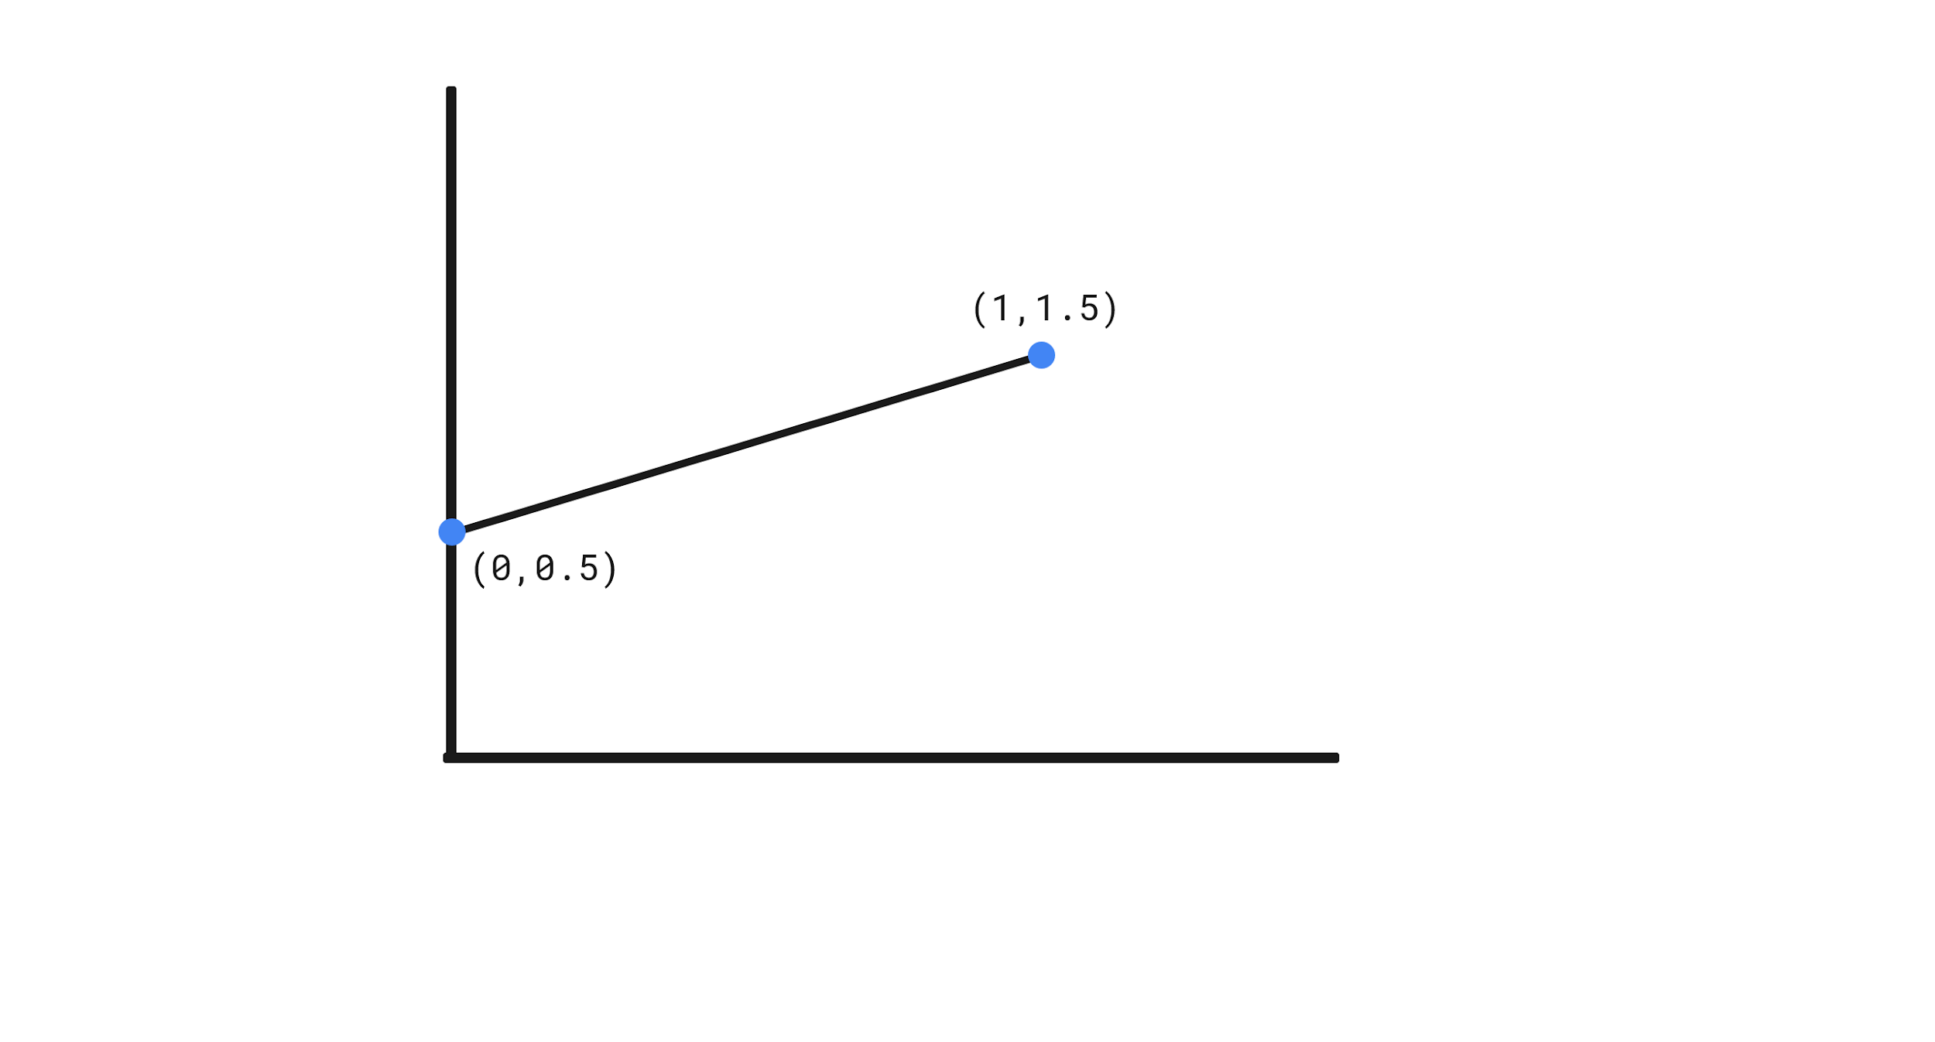
2. The CDF for y is just the the indefinite integral of the PDF of y from the lower bound of the support to some variable y: $\int_{0}^{y}{}(x+\frac{1}{2})dx=\frac{1}{2}y^{2}+\frac{y}{2}→F_{y}(y)= \frac{1}{2}y^{2}+\frac{y}{2} for 0≤x≤1, otherwise 0.$

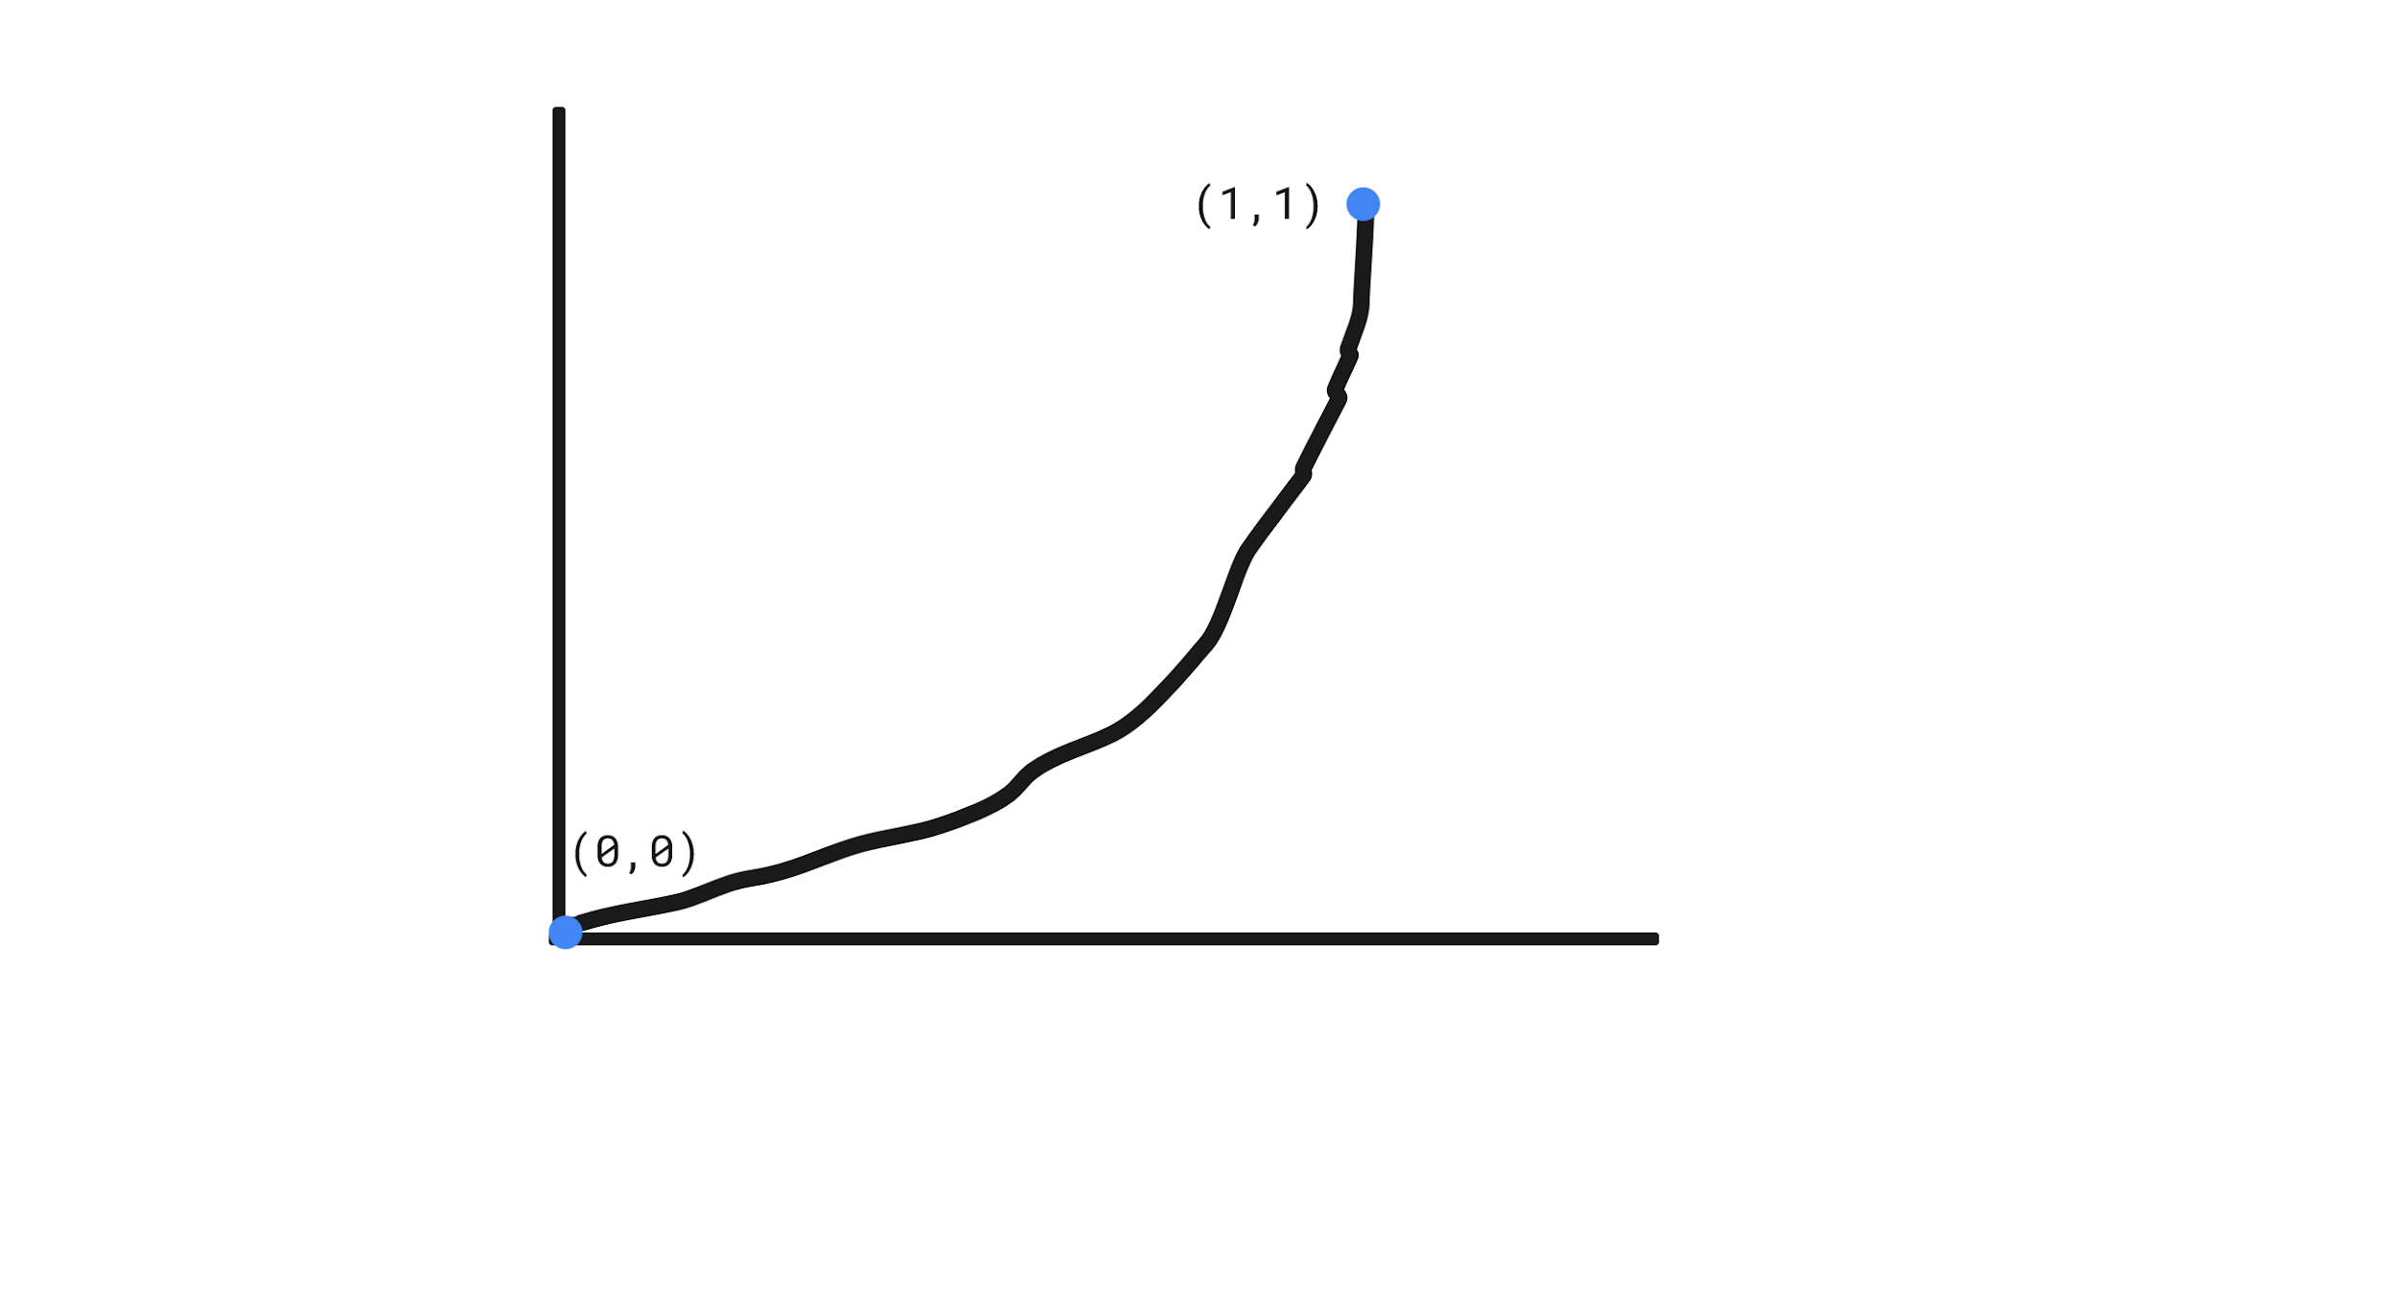

1. Using an inverse function calculator I found the quantile function to be: $F_{y}^{-1}(p)=\frac{\sqrt{1+8p} - 1}{2} for 0<p<1, otherwise 0.$

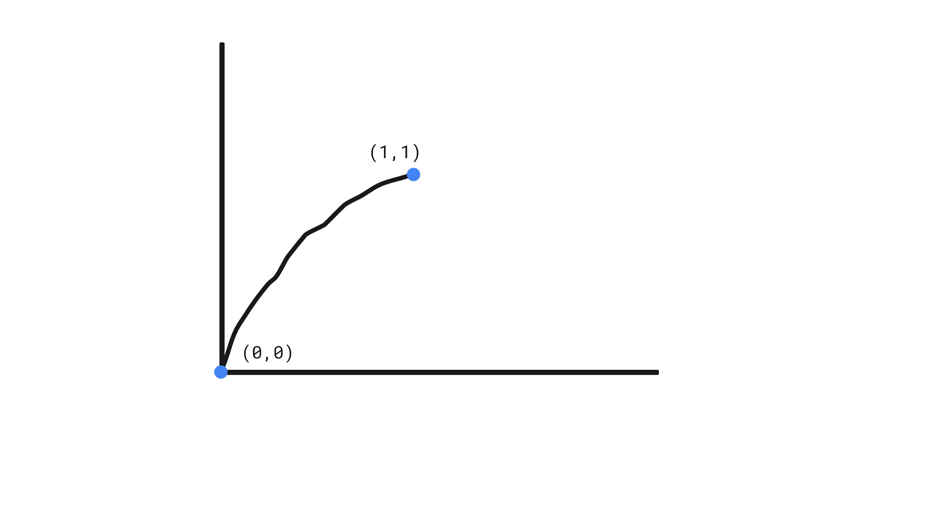

1. You use a random number generator to generate a random probability across the support, and then when you plug this into the inverse function from (c) and you get an IID random draw.
2. You take the y values from the inverse cdf from 0 to 1 and then graph them on a histogram and if it has the same distribution as the cdf then it is the correct inverse function.